Step by Step

* Create Maven project

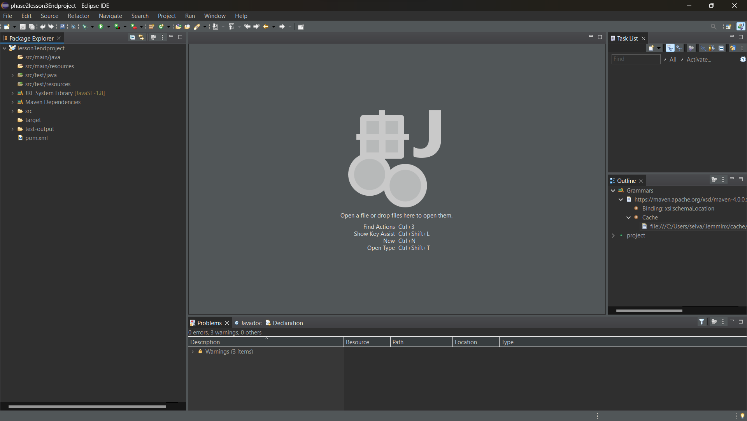

* 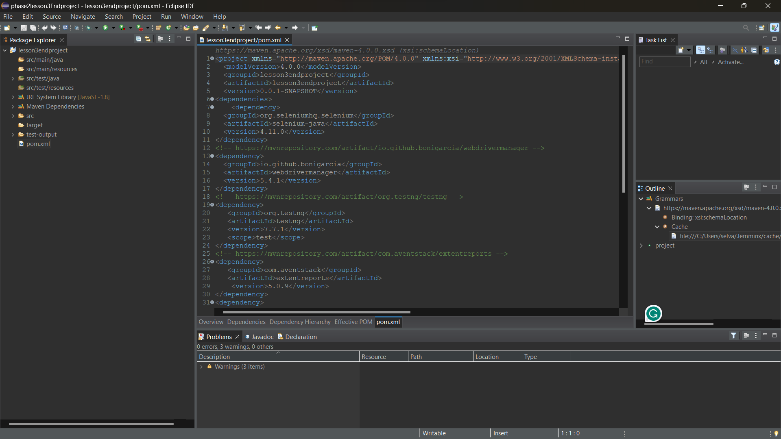Create Dependency
* 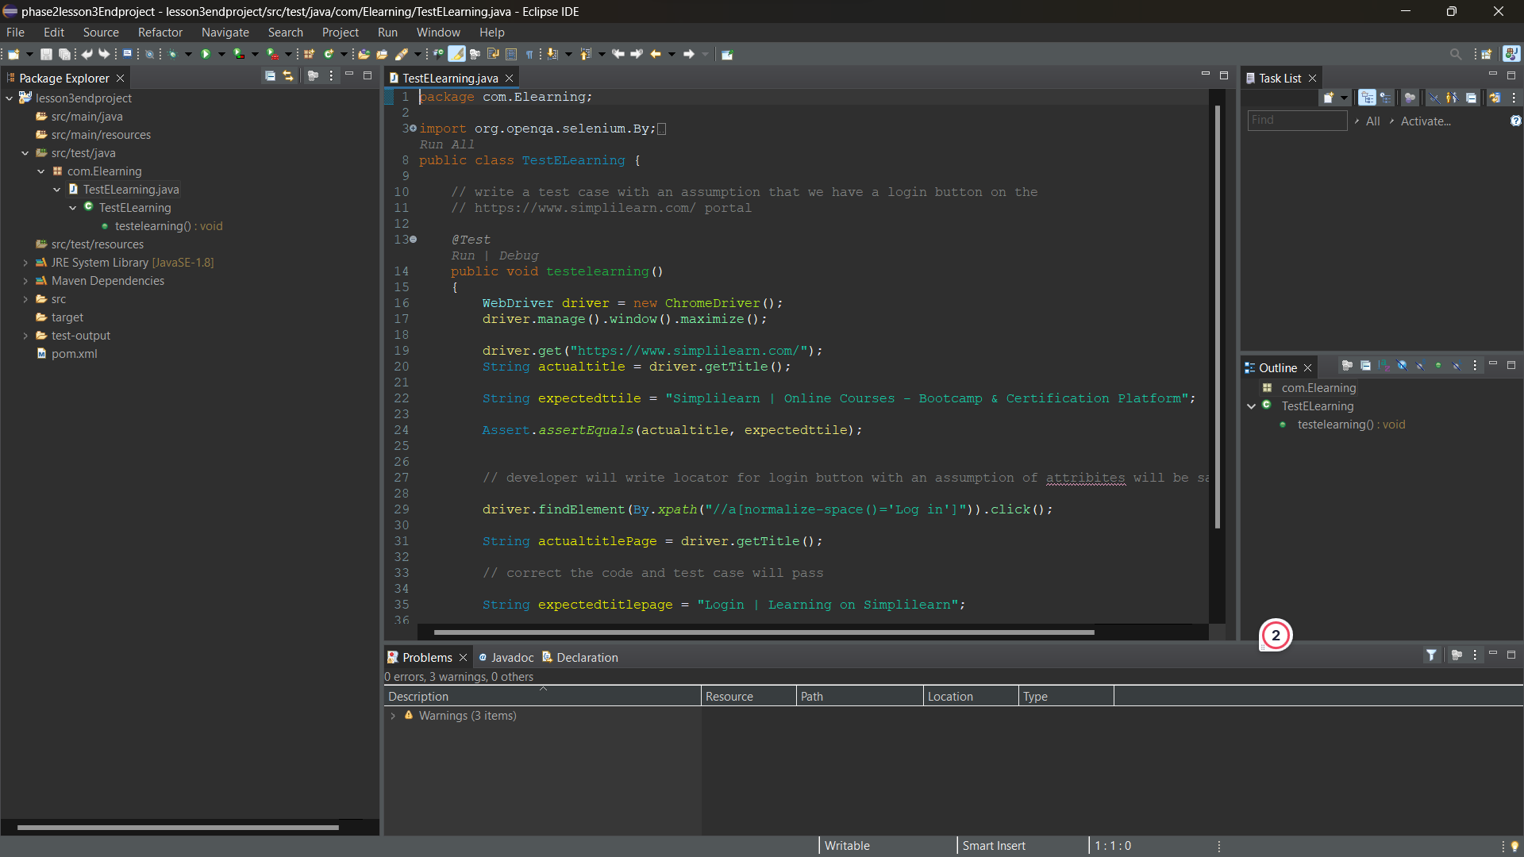Create Package and class
* 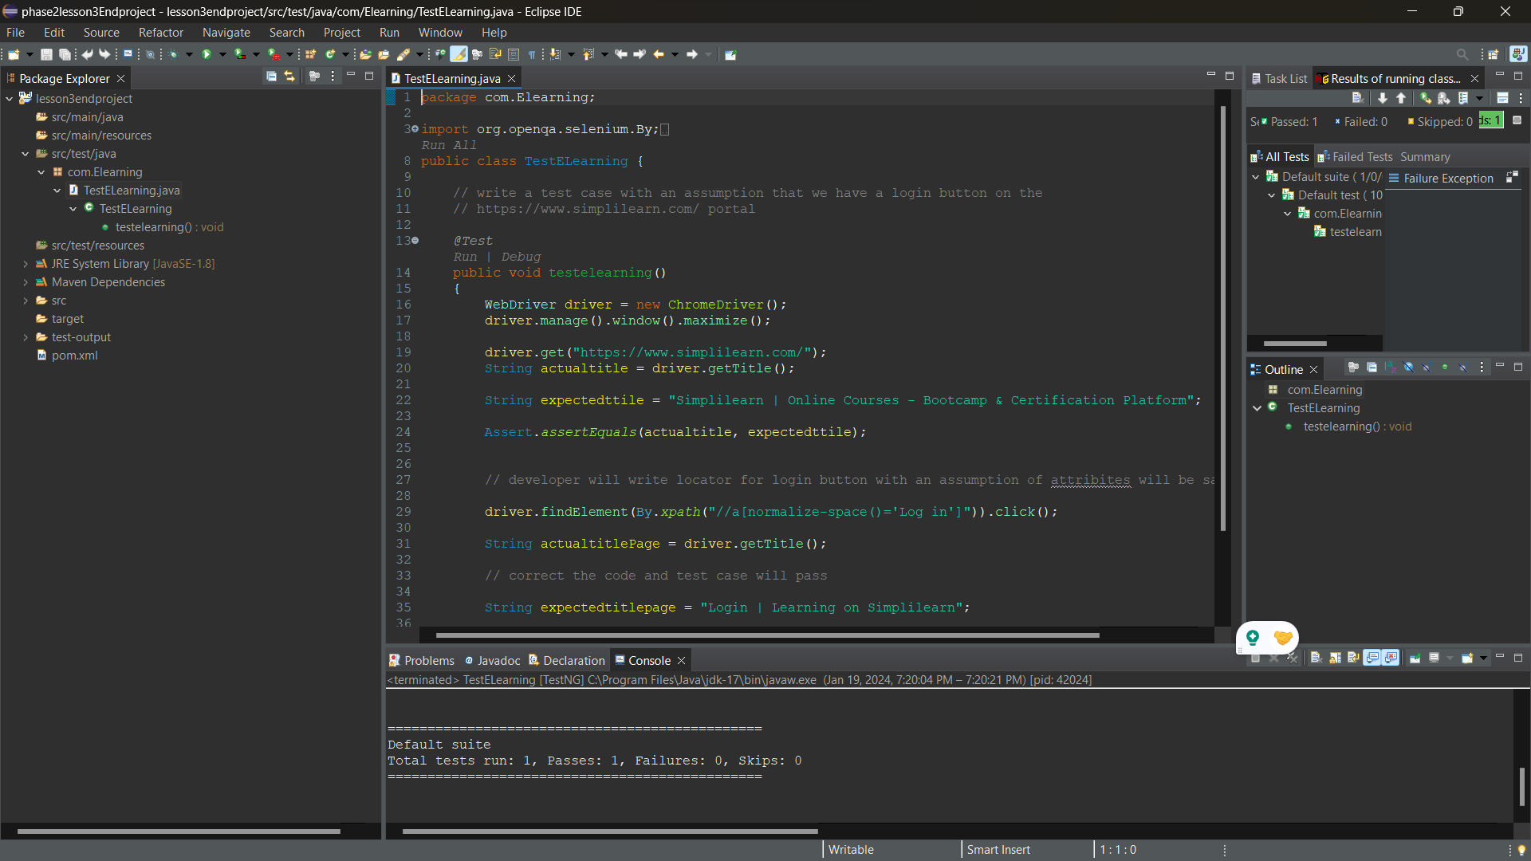Output
* **Github repositoory**

<https://github.com/Selvakumar9500/phase2lesson3endproject.git>